Assignment 3: Prototyping

Jamel Douglas

LIS 4351: User Experience Design

Professor Rebekah Dorn

December 5, 2021

Word Count: 1469

**Product Description**

My product is a home automation interface and control panel that will allow the user to view information and control their smart home devices. It will feature a touchscreen tablet style device that gets installed on a wall or into a stand for tabletop usage. Its touchscreen control panel will allow the user to connect to their smart home devices and control those devices from the panel. The control panel will integrate with Google Home and Amazon Alexa which allows for maximum compatibility with all smart home devices (such as Philips Hue and Aqara). The control panel will work like how most touch screen interfaces work. The user will be able to tap to toggle, or to press and hold for more options. When a user selects more options, it will open a menu that allows the user to select various options relating to the device. The control panel will be completely customizable, the user can set which buttons appear on the home screen, and these buttons can be set to a certain size. This is so that the user can set the interface to match their needs.

**User**

Our user is Robert, a 27-year-old corporate employee who lives in Atlanta, Georgia. He and his wife recently had their first kid and just bought their first house for his family to grow in. He was raised in technology era and has a good understanding of technology. Robert finds technology fascinating and thus has taken the time to upgrade most devices in his house to newer smart home variants, creating an immersive smart home experience. He has his control panel setup in his bedroom and has it setup to be a way for him to view the status of his home and to control various devices from the comfort of his bedroom.

**Scenario**

Robert is winding down for the night and about to go to bed. Robert takes one last glance at the control panel to get a quick status of the house. The control panel allow him to see the status of various smart home devices throughout his house. While looking at the panel, he notices that the front door was unlocked and that the garage door was left open. Robert uses the control panel to lock his front door and to close his garage door. All Robert had to do is to click on the icon on the dashboard to toggle the action relating to it, so pressing on the front door would lock the door and pressing on the garage door would close the garage door. Robert didn’t have to get up to check the statuses of these entry points of his house, and he also did not have to get up to remedy these problems. This is all possible because Robert upgraded the front door lock and the garage door opener to smart home enabled versions after his family moved into the house.

**Prototype**

**The Hardware**

The first place to start is the physical device that the user will be interacting with. The device is a nine-inch touchscreen tablet loaded with the software. The device comes equipped with a camera, microphone, and a presence detection sensor. Included with the device are the wall mounting bracket and necessary hardware, a tabletop stand, and the device’s power adapter. The wall mounting bracket is the primary placement method, which allows the user to affix the device to the wall. The bracket gets affixed to the wall by mounting the bracket to a stud. If a stud is not available in the desired location, the user can use the included drywall anchors to attach it to just the drywall. The tabletop stand allows for an alternative placement method, allowing the user to place the device on a tabletop or countertop. This alternative method is perfect for users who would not like to modify their wall.

**The Software**

The software is what enables the device to provide the user with the complete experience. The main goal of this product, and its software, is to improve the users smart home experience while also being done in a manner that is familiar to them. The setup of the device is quite simple. The device will power on once it is plugged into power. From there it will direct the user through the setup process. This process includes creating an account with our service and then linking that account with the various accounts for the user’s smart home devices (e.g. Google Home, Amazon Alexa, Philips Hue, etc.). Once the setup is complete, the user’s main dashboard is displayed and will be populated with icons for each device that was linked to their account. From here the user can customize their dashboard to their liking, similarly to how they would customize their home screen on their smartphone. Pressing and holding on an icon will allow the user to edit their dashboard, like placing the icons in a specific order by dragging and dropping the icons or moving some icons to a secondary dashboard screen they can swipe to by swiping to the right or holding an icon to the right. Also, once the user enters the dashboard editing mode, a menu icon will appear in the top right which will allow the user to enter the settings menu. Once the device is customized to the users liking, all they must do is walk up to the screen, which will awake from sleep mode due to the presence detection sensor and tap on an icon to interact with their smart home. A couple of minutes after the user walks away from the device, the screen will dim, and it will enter the sleep mode.

**The Prototype**

Included below is a photo of the products wireframe prototype, which is somewhat specific to the user’s (the user described above) needs.

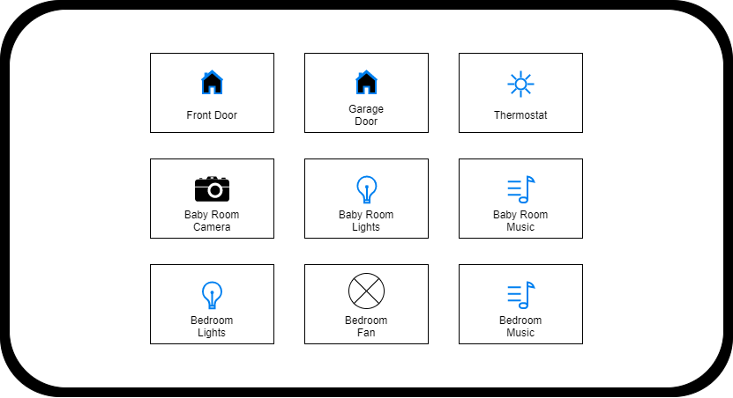

**Rationale**

The main reason that this product came to life was after I had personally gotten into smart home devices. My one big problem was my interface to interact with my devices, voice assistants. Voice assistants, like Google Home, are a great addition to a smart home but they become a problem when I have to ask it three times to turn my lights on. It was frustrating to not do something as simple as turning on my lights. I guess my smart home was lacking something rudimentary, like a light switch. This product aims to solve this situation for others, a physical way to interact with their smart home.

The ideal mounting method for this device is on a wall using the included wall mounting bracket. I mean this product came to life because of my lack of a “smart” light switch. This became the first problem in the design process. It was quickly realized that every user might not be in a situation where they can modify the walls in their smart home, or some just prefer not to do so. That is why a secondary mounting method, the tabletop stand, is included with the device.

The last issue was the software experience. The goal is for the experience to be as familiar to the user as possible as there could be users who are less technologically inclined. The first step in this process was to implement a setup process that walks the user through all the steps to setup the functionality of the device. This is something users should recognize from dealing with other technology devices. The next thing was the customization process. The user activates it by pressing and holding on any icon and moves icons by pressing on them and dragging it to the desired location. This should also be very familiar to the user. Lastly, interacting with the device is done by just simply pressing on the desired icon. This should also be familiar to the user.

With all this in mind, I believe that the user should be able to complete their required scenario of locking his front door and closing his garage door from his bedroom.

**Conclusion**

Moving forward, the next step in the process is to create a working prototype to continue with the process of designing and testing the software. Once a beta version, which is a somewhat working version of the software, is ready then the process moves on to hardware design and testing, where a rough prototype is first made. This is when the hardware prototype and the software get combined as one. From there more testing and designing will be done to both the software and hardware as a combined unit to help create a final working product that will meet the needs of our users.

One thing that I learned throughout this process was I think the idea of having multiple wireframes/prototypes to illustrate different actions that I ended up describing in my description. It would probably help others visualize what I am talking about.